**Bash Lab1**

**Q1: Display the lines that contain the word "lp" in /etc/passwd file:**

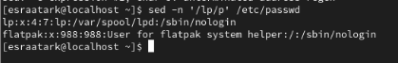

**Q2: Display /etc/passwd file except the third line:**

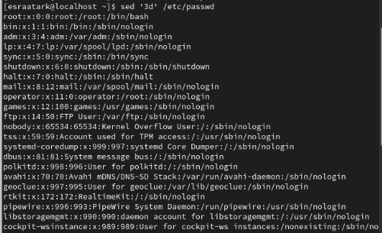

**Q3: Display /etc/passwd file except the last line:**

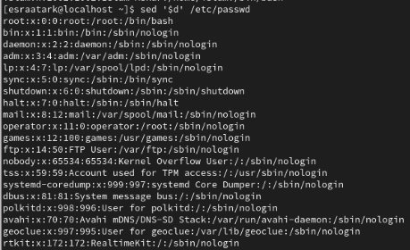

**Q4: Display /etc/passwd file except the lines that contain the word "lp":**

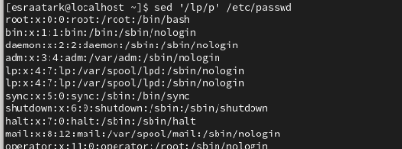

**Q5: Substitute all the words that contain "lp" with "mylp" in /etc/passwd file:**

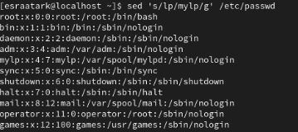

**Q1:**  **Print full name (comment) of all users in the system:**

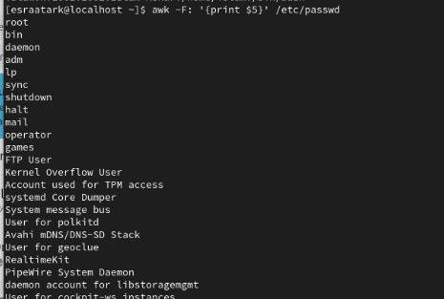

**Q2:**  **Print login, full name (comment) and home directory of all users.( Print each line preceded by a line number)**

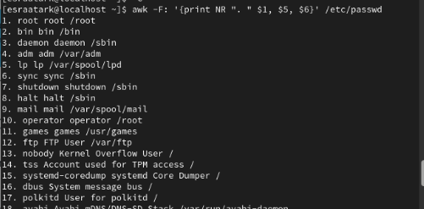

**Q3:**  **Print login, uid and full name (comment) of those uid is greater than 500**

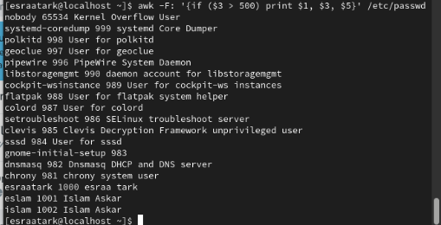

**Q4:**  **Print login, uid and full name (comment) of those uid is exactly 500**



**Q5:**  **Print line from 5 to 15 from /etc/passwd**

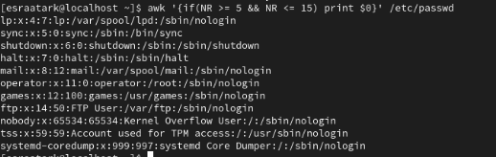

**Q6:**  **Change lp to mylp**

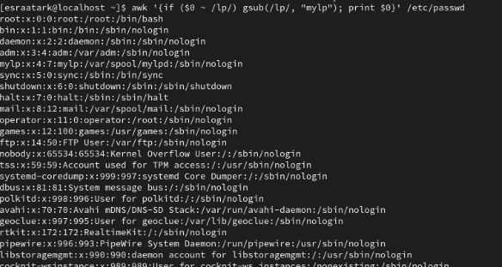

**Q7:**  **Print all information about greatest uid.**



**Q8:**  **Get the sum of all accounts id’s.**



**Bonus**

**1. Get the sum of accounts id’s that has the same group.**

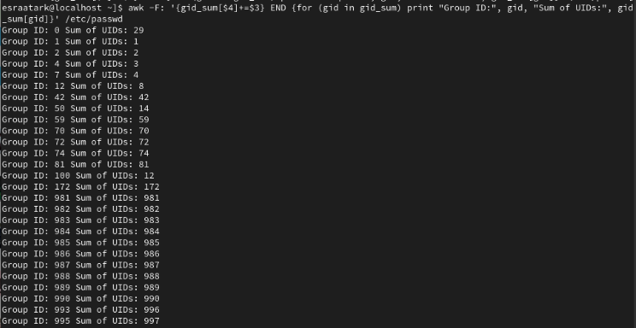

**2. Make the following report:**

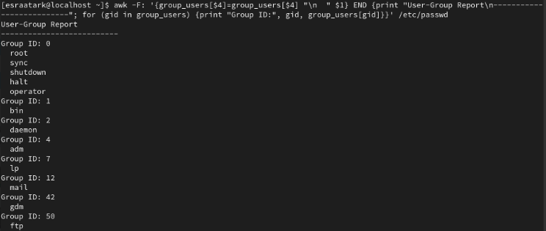

Esraa tark foda - OS